Architecture Design

**HR Analytics - Turnover**

|  |  |
| --- | --- |
| **Written By** | Pawan Nagar |
| **Document Version** | 1.0 |
| **Last Revised Date** | 31-03-2023 |

# DOCUMENT CONTROL

**Change Record:**

|  |  |  |  |
| --- | --- | --- | --- |
| **VERSION** | **DATE** | **AUTHOR** | **COMMENTS** |
| 0.1 | 20- March-  2023 | Pawan Nagar | Introduction and architecture defined |
| 0.2 | 21- March-  2023 | Pawan Nagar | Architecture |
| 0.3 | 22- March-  2023 | Pawan Nagar | Power Bi Server Architecture |
| 0.4 | 24- March-  2023 | Pawan Nagar | Deployment Description |
| 1.0 | 31- March-  2023 | Pawan Nagar | Done |

**Reviews:**

|  |  |  |  |  |  |  |  |  |
| --- | --- | --- | --- | --- | --- | --- | --- | --- |
| **VERSION** | **DATE** |  | **REVIEWER** |  | **COMMENTS** | | |  |
|  |  |  |  |  |  | | |  |
| **Approval Status:** | |  |  |  |  | | |  |
| **VERSION** | **REVIEW DATE** |  | **REVIEWED BY** |  |  | **APPROVED BY** |  | **COMMENTS** |
|  |  |  | |  | |  |  | |

# Contents

## 1. Introduction………………………………………………………………………………………………………… 04

**1.1 What is Architecture Design Document? ………………………….………………………………. 04**

**1.2 Scope ………………….………………………………………………………………………………………….... 04**

## 2. Architecture ………………………………………………………………………………………………………. 05

**2.1 Power Bi Architecture …………………….……….………………………………………………………. 05**

**2.2 Power Bi Server Architecture………………….……………….…………………….…………………. .05**

**2.3 Data Preparation: - …………………………………….………………………………………………... ... 06**

**2.4 Transform …………………….………………………………………………………….……………………. …06**

**2.5 Data Warehouse …………………….………………………………………………………………….….…. 06**

**2.6 Visualization………………………………………………………………………………………………………. 06**

**2.7 Process Flow of Power Bi ………………………………………………………………………………...….07**

## 3. Deployment ………………...………………………………………….……………………………………………07

**3.2 Deployment options in Power Bi …………………………………………………………….………… 07**

**3.3 File Share ………………………………………………………….………………………………………......….09**

**3.4. SharePoint …………………….……………………………………………….……………………….……...09**

**3.5 Third Party Integration………………………………………………………………………………………...09**

**4. Hybrid Deployment………………………………………………………………………………………………09**

**4.1. Power BI Service………………………………………………………………………………………………….10**

**4.2. Custom Application Integration………………………………………………………….10**

# 1. Introduction

**1.1 What is Architecture design document?**

Any software needs the architectural design to represents the design of software. IEEE defines architectural design as “the process of defining a collection of hardware and software components and their interfaces to establish the framework for the development of a computer system.” The software that is built for computer-based systems can exhibit one of these many architectures.

Each style will describe a system category that consists of :

* A set of components (eg: a database, computational modules) that will perform a function required by the system.
* The set of connectors will help in coordination, communication, and cooperation between the components.
* Conditions that how components can be integrated to form the system.
* Semantic models that help the designer to understand the overall properties of the system.

## 1.2 Scope

Architecture Design Document (ADD) is an architecture design process that follows a step-by-step refinement process. The process can be used for designing data structures, required software architecture, source code and ultimately, performance algorithms. Overall, the design principles may be defined during requirement analysis and then refined during architectural design work.

# 2. Architecture

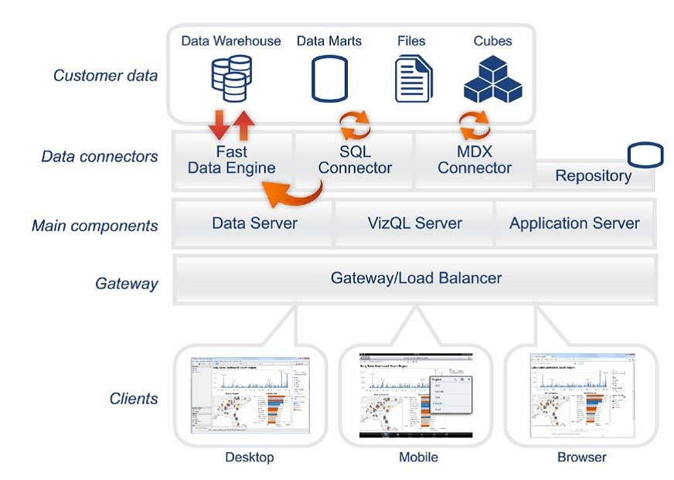

# Power Bi Server Architecture

Power BI architecture is a service built on top of Azure. There are multiple data sources that Power BI can connect to. Power BI Desktop allows you to create reports and data visualizations on the dataset. Power BI gateway is connected to on premise data sources to get continuous data for reporting and analytics.

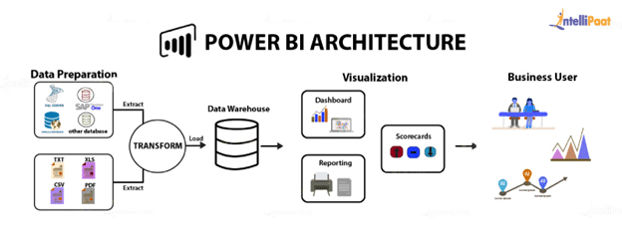The following diagram shows Power Bi Server’s architecture:

Power Bi Server is internally managed by the multiple server processes.

## Data Preparation: -

Self-service data prep for big data in Power BI – Data flows can be used to easily ingest, cleanse, transform, integrate, enrich, and schematize data from a large array of transactional and observational sources, encompassing all data preparation logic.

## Transform: -

Power BI Desktop to access SAP Business Warehouse (SAP BW) data. The SAP BW Connector Implementation 2.0 has significant improvements in performance and capabilities from version 1.0. Power BI Report Server is an on-premises report server with a web portal in which you display and manage reports and KPIs. Along with it come the tools to create Power BI reports, paginated reports, mobile reports, and KPIs. Your users can access those reports in different ways: viewing them in a web browser or mobile device, or as an email in their in-box.

## Data Warehouse: -

A data warehouse is a type of data management system that is designed to enable and support business intelligence (BI) activities, especially analytics. Data warehouses are intended to perform queries and analysis and often contain large amounts of historical data.

## Visualization

Data visualization brings data to life, making you the master storyteller of the insights hidden within your numbers. Through live data dashboards, interactive reports, charts, graphs, and other visual representations, data visualization helps users develop powerful business insight quickly and effectively.

## Process Flow of Power Bi

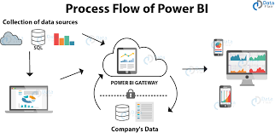

# 3. Deployment Description

## 3.1 Deployment options in Power Bi

Power BI is a business suite that includes several technologies that work together. To deliver outstanding business intelligence solutions, Microsoft Power BI technology consists of a group of components such as:

### **Data Sources**

An important component of Power BI is its vast range of data sources. You can import data from files in your system, cloud-based online data sources or connect directly to live connections.

* Excel Text/CSV XML
* JSON
* Oracle Database
* IBM DB2 Database
* MySQL Database
* PostgreSQL Database
* Sybase Database
* Teradata Database etc.

### **Power BI Service**

Power BI Service is a web-based platform from where you can share reports made on Power BI Desktop, collaborate with other users, and create dashboards.

* Free version
* Pro version
* Premium versionaca

### **Power BI Desktop**

Power BI Desktop is a client-side tool known as a companion development and authoring tool. This desktop-based software is loaded with tools and functionalities to connect to data sources, transform data, data modelling and creating reports.

We should be able to address these questions satisfactorily for a successful sales pitch. To answer these questions, we should be aware of the deployment models of Power BI. In this blog let us go through these aspects of Power BI.

We need to first understand generic deployment models

* **On-Premises:** Refers to data, applications and infrastructure entirely owned by client at client data centre and client has complete control over it.
* **Cloud:** Refers to data, infrastructure and/or services residing in a public cloud environment and completely managed /controlled by third party. Microsoft Azure and web based Power BI service are examples of the cloud offerings.
* **Hybrid:** This denotes to the implementation which spans both on premises and cloud sources which can be services, infrastructure and data sources

Power BI supports all three types of models. Let us see how this is possible and exactly what is to be done.

**On-Premises Deployment:**

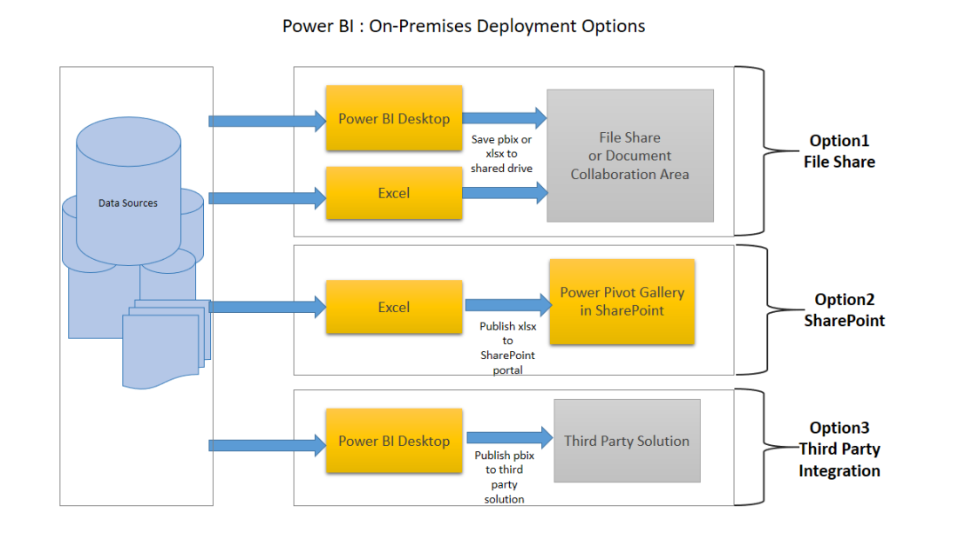

**Option 1 : File Share**

The first on-premises option involves usage of a file share: Data preparation and report creation is done in client tools: Power BI Desktop and/or Excel.

The completed Power BI Desktop and/or Excel file is published to a file share or a document collaboration area / repository.

To view the reports, Excel or Power BI desktop has to be installed on the viewer’s machine

**Option 2: SharePoint**

The second on-premises option involves a specialized document library in SharePoint called the Power Pivot Gallery. Due to my limited knowledge, I am not going in details of this option

* Data preparation and report creation occurs in Excel.
* The completed Excel file is published to SharePoint within a Power Pivot Gallery.

**Option 3: Third Party Integration**

The third on-premises option involves a third party which integrates with Power BI.

* Data preparation and report creation occurs in Power BI Desktop.
* The completed Power BI Desktop file is published to the third party server

**4.Hybrid Deployment**

Power BI can be deployed in hybrid mode in three different options. Kindly refer below diagram.

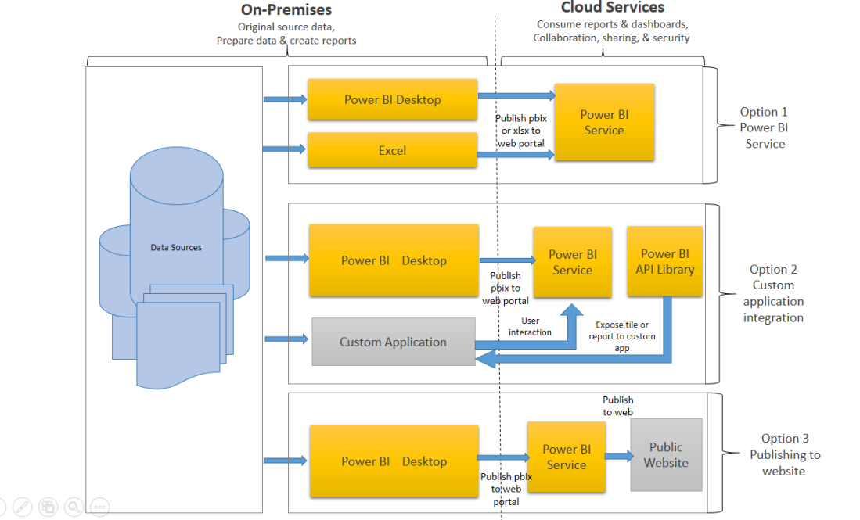

**Option 1: Power BI Service**

* Data is either from the on premises corporate applications or it might be born in cloud. It can even mix of these two
* Data preparation and report creation occurs in Power BI Desktop or excel
* Completed Power BI reports are then published to Power BI service
* Report consumption, sharing, security, collaboration, data refresh happens in Power BI service
* Dashboards are created in Power BI service and reports can also be edited or created in Power BI service

**Option 2: Custom Application Integration**

* Data is either from the on premises corporate applications or it might be born in cloud. It can even mix of these two
* Data preparation and report creation occurs in Power BI Desktop
* Completed Power BI reports are then published to Power BI service
* An embed code is generated by Power BI service for selected report and this code can be embedded in web page of the website within Frame
* Here no security is maintained as its public website, hence suitable for the data which can be made publicly available

.